**EEG Based Depression Detection Using Machine Learning Techniques**



**Department of Computer Science and Engineering**

**January 2024**

**Supervisor**

**Md. Khademul Islam Molla, PhD**

Coordinator

Department of CSE

Varendra University

Rajshahi, Bangladesh

**Researcher**

Md. Hasibul Hasan

ID: 201311067

Md. Yusuf Hasan

ID: 201311094

Mst. Taslima Akter

ID: 201311139

Department of CSE

Varendra University

Rajshahi, Bangladesh



**Certificate**

This thesis entitled “EEG Based Depression Detection Using Machine Learning Techniques” was done by Md. Hasibul Hasan (201311067), Md. Yusuf Hasan (201311094), Mst. Taslima Akter (201311139) and was submitted to Department of Computer Science and Engineering, Varendra University, Rajshahi as Partial Fulfillment of the Requirements for the Award of the Degree B.Sc. In CSE.

**Supervisor**

**Md. Khademul Islam Molla, PhD**

Coordinator

Department of CSE, Varendra University

**I**

**Declaration**

We hereby declare that the undergraduate research work reported in this thesis has been performed by us under supervision of **Md. Khademul Islam Molla, PhD**, Coordinator, Dept of CSE, Varendra University, Rajshahi. This thesis was prepared, written and entirely the result of our own work.

We express our sincere thanks to our supervisor **Md. Khademul Islam Molla, PhD** for his novel association of ideas, encouragement, appreciation, and intellectual zeal which motivated us to venture into this thesis successfully.

**II**

**Contents**

|  |  |  |  |  |
| --- | --- | --- | --- | --- |
| **Certificate** | | | | **I** |
| **Declaration** | | | | **II** |
| **List of Figures** | | | | **V** |
| **List of Tables** | | | | **VI** |
| **List of Algorithms** | | | | **VII** |
| **Abstract** | | | | **VIII** |
| **1** | | **Introduction** | | **1** |
|  | 1.1 | | Introduction to Depression | 2 |
|  | 1.2 | | Introduction to EEG | 2-3 |
|  | 1.3 | | Depression Detection Overview | 4 |
|  | 1.4 | | Motivation of the Thesis | 4 |
|  | 1.5 | | Proposed Research Method | 5 |
|  | 1.6 | | Objectives of the Thesis | 5 |
|  | 1.7 | | Contribution | 5 |
| **2** | **Literature Review** | | | **6** |
|  | 2.1 | | Introduction | 7 |
|  | 2.2 | | Challenges | 7 |
|  | 2.3 | | Related Works | 7 |
|  | 2.4 | | Conclusion | 8 |
| **3** | **Dataset** | | | **9** |
|  | 3.1 | | Overview of Dataset | 10 |
| **4** | **Methodologies** | | | **11** |
|  | 4.1 | | Introduction | 12 |
|  | 4.2 | | Data Processing | 12 |
|  | 4.3 | | Label Datastore | 13 |
|  | 4.4 | | Feature Datastore | 13 |
|  | 4.5 | | Classification Models | 14 |
|  | 4.6 | | Random Forest Model | 14-15 |
|  | 4.7 | | XGBoost Model | 16-17 |
|  | 4.8 | | Evaluation of Training Models | 18-19 |
| **5** | **Results** | | | **20** |
|  | 5.1 | | Introduction | 21 |
|  | 5.2 | | Random Forest Model Result | 21 |
|  | 5.3 | | XGBoost Model Result | 22 |
|  | 5.4 | | Discussion of Training Results | 23 |
|  | 5.5 | | Comparative Analysis | 23 |

**III**

|  |  |  |  |
| --- | --- | --- | --- |
| **6** | **Conclusion and Future work** | | **24** |
|  | 6.1 | Conclusion | 25 |
|  | 6.2 | Limitation | 25 |
|  | 6.3 | Future work and Direction | 25 |
| **7** | **References** | | **26-27** |

**IV**

**List of Figures**

|  |  |  |
| --- | --- | --- |
| 1.1 | Example of depression patients | 2 |
| 1.2 | EEG signal recording process | 3 |
| 1.3 | A Generalized Block Diagram of EEG Based depression detection | 4 |
| 4.1 | Overview of Random Forest Model | 15 |
| 4.2 | Overview of XGBoost model | 17 |
| 5.1 | Confusion matrix of RF model | 21 |
| 5.2 | Confusion matrix of RF model | 21 |
| 5.3 | Confusion matrix of XGBoost Model | 22 |
| 5.4 | ROC Curve of XGBoost Model | 22 |

**V**

**List of Tables**

|  |  |  |
| --- | --- | --- |
| 4.1 | Participants data frame. | 12 |
| 4.2 | Selected Participants data frame | 12 |
| 4.3 | label Datastore | 13 |
| 4.4 | Feature Datastore | 13 |
| 4.5 | Feature Datastore. (cont…) | 13 |
| 4.6 | Parameter of Random Forest Model | 15 |
| 4.7 | Parameter of XGBoost Model | 17 |
| 5.1 | Evaluation of Random Forest model | 21 |
| 5.2 | Evaluation of XGBoost model | 22 |
| 5.3 | List of a few Recent Works | 23 |

**VI**

**List of Algorithms**

|  |  |  |
| --- | --- | --- |
| 4.1 | Random Forest model algorithm | 15 |
| 4.2 | XGBoost model algorithm | 17 |

**VII**

**Abstract**

Depression has become a global public health concern in recent years, affecting millions of people all over the world. That's why depression detection has become a crucial step in analyzing as well as diagnosing depression among patients, ensuring better treatment and support for their mental health condition. Our present study focuses on developing algorithms that can recognize depression patterns by studying Electroencephalogram (EEG) data and investigates the potential of Electroencephalogram (EEG) data in depression detection. Understanding and predicting depressive symptoms in patients is challenging because brain signals (EEG) are complicated and constantly changing. Additionally, differences in age and gender among patients add to the complexity. Creating an accurate and effective prediction, as well as visually representing depressive conditions in patients, becomes difficult due to these factors. Our EEG signal data are collected from Kaggle and are used to study depression which is a subcategory of mental diseases highlighted in the dataset. Here 5 minutes eye closed resting state EEG data collected from 19 channels with 500 sampling rate. In this study, we employed two robust machine learning models, Random Forest and XGBoost, to analyze the EEG data for depression. Among them XGBoost has shown 82.5% accuracy rate with the given dataset where Random Forest has 81.25% accuracy.

**Keywords:** Depression detection, Electroencephalogram (EEG), Machine learning, Random Forest, XGBoost, Depressive disorder.

**VIII**

**Chapter 1**

**Introduction**

* 1. **Introduction to Depression**

Depression doesn’t mean just feeling sad or losing interest in something, instead depression is related to a person’s everyday life. It may create a feeling that can make everything seem overwhelming and joyless. It generates difficulty functioning in regular activity and affects a person's thoughts, feelings, and behavior. So, to get rid of depression, depression detection, and diagnosis have become a very needy and trendy issue. It needs proper treatment and guidance to ensure a normal life for every affected patient.



Figure 1.1: Example of depression patient

* 1. **Introduction to EEG**

Depression is often diagnosed based on self-reported symptoms, clinical interviews, and observations by mental health professionals so-called psychiatrists. But brain signals called EEG (Electroencephalogram) help a lot in detecting as well as analyzing this mental health condition. It is a gift of technological advancement for present days. In previous research, it is shown that individuals with depression often exhibit distinct patterns in their EEG signals compared to those without the disorder. These patterns may include specific frequency alterations, changes in connectivity between brain regions, and variations in the overall electrical activity of the brain. Researchers have been trying to identify the indicators of depression in brain signal behaviors. The more acceptable scenario can be something like, increased theta and alpha wave activity or decreased beta wave activity in certain brain regions may be associated with depressive symptoms. Coherence is an important part of EEG that helps to identify neuronal correlation and measures relationships between bandwidths of EEG signal collected from the scalp using electrodes. Coherence is a measure of the linear relationship between two signals at different frequencies. In the context of EEG, it is often used to quantify the degree of synchronization between different brain regions. High coherence indicates a strong linear relationship or synchronization between the electrical activities of two brain regions at a specific frequency. Low coherence, on the other hand, implies a weak or absent linear relationship between two EEG signals at a specific frequency which refers to independent activity. Coherence in EEG provides an effective process for analyzing depression using brain activity. Several Key EEG frequency bands associated with depression detection are Delta(0.5-4Hz), Theta(4-8Hz), Alpha(8-13Hz), Beta(13-30Hz) and Gamma(30-40Hz). Delta waves are associated with deep sleep and unconscious. Increased delta activity in certain brain regions may be observed in individuals with depression. Theta waves are more generally associated with relaxation. However the abnormal amount of theta activity can be associated with depression. Alpha bands are more generally associated with Relaxation and mental calmness. But in a depressed patient Reduced alpha activity, particularly in frontal and parietal regions, is often observed. Beta waves are mostly associated with active thinking, and concentration. Abnormal beta activity, especially in frontal and central regions may point to depression symptom. Finally comes the Gamma. I our study we didn’t directly use Gamma as feature to train ML models though Gamma is associated with depression detection using EEG. Altered gamma activity patterns are related to depression.

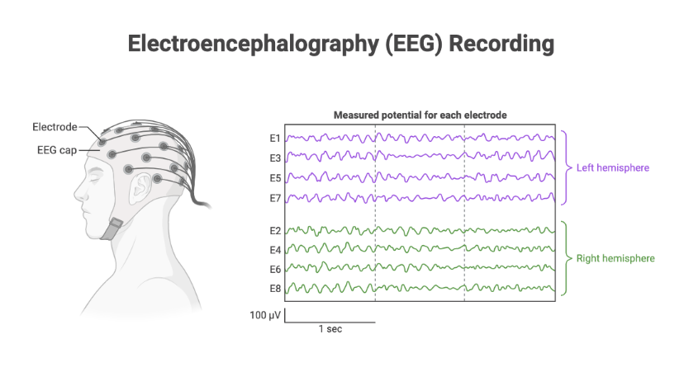

Figure 1.2: EEG signal recording process.

* 1. **Depression detection overview.**

A typical Block diagram to show depressive and non-depressive patients using machine learning models that we’ve used are shown below.

Data

Split data

Training

Testing

Train Model using parameter

Creating decision treess

Classifiers

Classification Result

Figure 1.3: A Generalized Block Diagram of EEG Based depression detection

In this study we’ve used secondary dataset from Kaggle for which 128 electrode-elastic cap is used for signal recording and 19 channels are considered for achieving EEG data. For our study 95 healthy participants are considered against 266 depressed patients.

**1.4 Motivation of the thesis**

With a view to the urgent need of enhancing our understanding and early identification of depression psychological assessment is a must. Traditional methods of diagnosing depression often rely on subjective assessments, leading to delayed intervention and treatment. By focusing on Electroencephalogram (EEG) signals, and employing Machine Learning Techniques, our study highlights the effectiveness of EEG data and model training mechanisms for better accuracy achievement in detecting depression.

**1.5 Proposed research method**

In our study two supervised Machine Learning models XGboost and Random Forest are investigated in order to evaluate EEG-based depression detection. With a focus on improving model accuracy and robustness, the research utilizes labeled datasets collected from Kaggle. This generates a foundation for the supervised learning task, where features are used and target labels are assigned. The aim of our study is contributing to the advancement of predictive modeling in the chosen domain.

**1.6 Objectives of the thesis**

Our base objectives of this thesis are as follows:

* Investigating the effectiveness of using EEG signals for depression analysis
* Optimizing machine learning models/techniques for improved accuracy

**1.7 Contribution**

The underlying contributions of our study is given as follows.

* A brief study on EEG signal processing and brain signal analysis with usage
* Machine Learning model application and recommendation based upon data analysis, accuracy measurement and prediction

**Chapter 2**

**Literature Review**

**2.1 Introduction**

This chapter provides an overview of how previous researches have looked into EEG signal and how Machine Learning techniques were utilized in order to detect depression among individuals. Brief about those works are highlighted and the analysis processes is described. What were the challenges and how accurate results were found will be discussed in this chapter.

**2.2 Challenges**

Even though EEG is one of the effective ways to predict and analyze depression and related mental health conditions, EEG signal is non-stationary, complex and hard to generalize because of the variation among people’s age, variation etc. Also very few researches were done on depression, most of the analysis were made only upon other mental health issues [2]. Large number of layers makes the system more complex additionally small amount of data is not sufficient for analyzing depressive status. The larger the data amount is the better the prediction becomes[8].

**2.3 Related Works**

EEG-based mental health condition analysis was a major discussion in the previous researches we've gone through so far. A research that focuses on higher depression detection model accuracy rate based on several machine learning techniques include 76% accuracy with random forest model when the rate is of 81% for XGboost model. This includes data preprocessing, feature details, and comprehensive model training for getting better analytical accuracy in detecting depressive patients[2]. Another research compares various EEG signal analysis techniques, compares their accuracy and methodology used. Also describes the major reason behind the wrong diagnosis of depression as the absence of any accepted biomarkers for Major Depressive Disorder or any other psychiatric disorder[4]. They also achieved great accuracy outcomes using ML technique models. Another research tried to establish novel classifiers for discriminating patients with major psychiatric disorders. They applied random forest for efficient accuracy achievement. They have obtained higher accuracy in the specific categories than in the large grouping categories of mental health conditions. The research also highlights the fact of EEG-based ML to be promising approach for the classification of psychiatric disorders[6].

**2.4 Conclusion**

According to our study on the previous papers that provides us the idea of EEG-based depression analysis using different Machine Learning techniques have given powerful accuracies for different datasets and different categorical models. Though very few of the analysis were made using EEG data and ML or DL models for depression detection. Most of the studies were done focusing upon other different mental health issues. A high/better amount of data is essential to ensure better accuracy also important to make the model more thoughtful and predictive. However, more research, data training, model evaluation is necessary in order to achieve better outcome in depression detection and prediction.

**Chapter 3**

**Dataset**

1. **1 Overview of Dataset**

A preprocessed EEG dataset is used for the investigation of mental disorders. Data was collected using 19 electrode channels from different scalp regions. Electrode elastic cap is common equipment used to collect EEG recordings. Electrode cap fitted over participant's scalp with 19 electrodes placed at specific locations according to the International 10-20 system. 10-20 system is an International standard for electrode placement. These electrodes detect electrical signals generated by the brain and transmit them to an amplifier, which amplifies the signals and converts them into digital data for further analysis. The data included 5-minute eye-closed resting states with 19 channels acquired with a 500 Hz sampling rate. FP1, FP2, F7, F3, Fz, F4, F8, T7, C3, Cz, C4, T8, P7, P3, Pz, P4, P8, O1, and O2. Here odd numbers are on the left side of the head and even numbers are on the right side. EEG data is converted to the frequency domain using the frequency range 0.5-40 Hz. EEG parameters were calculated using six frequency bands delta (1-4 Hz), theta (4-8 Hz), alpha (8-12 Hz), beta (12-25 Hz), highbeta (25-30 Hz), gamma (30-40 Hz). At the time of preprocessing noise and artifacts are removed.

In the dataset, there are PSD (Power Spectral Density) columns for 19 channels using 6 frequency bands which contain (19*6) = 114 columns. Also, there is coherence in the columns. Coherence is measured between every pair of electrodes of each frequency band. Consider n = 19 so the contains values are (n(n-1)/2), (19(19-1)/2) = 171. Which contain (171*6) = 1026 coherence columns.

This preprocessed dataset considers a total of 945 participants recording. where 95 participants are healthy control, 266 participants are depressive disorder, and more than 584 participants fall into some other disorders like (anxiety, schizophrenia, addictive, etc).

**Chapter 4**

**Methodologies**

**4.1 Introduction**

This chapter provides, an overview of working procedures that have been constructed for prediction depression using EEG signals. A brief detail was provided about data processing for the analysis. Overview of Machine Learning models used for this research. This chapter also provides machine learning uses to train a model and classify depression and health control.

**4.2 Data Processing**

We are using preprocessed data. So doesn’t need to perform any filter operation to remove noise and artifacts. This analysis based on depressive disorder and healthy control so we used on depressive disorder and healthy control participants. We found totally 266 depressed and 95 healthy control participants.

**Table 4.1:** Participants data frame.

|  |  |  |  |  |  |  |
| --- | --- | --- | --- | --- | --- | --- |
| **S_No** | **Sex** | **Age** | **EEG Date** | **Education** | **IQ** | **Main Disorder** |
| 1 | M | 57 | 2012.8.30 | NA | NA | Addictive disorder |
| 2 | M | 37 | 2012.9.6 | 6 | 120 | Addictive disorder |
| 3 | M | 32 | 2012.9.10 | 16 | 113 | Addictive disorder |
| 4 | M | 35 | 2012.10.8 | 18 | 126 | Addictive disorder |
| 5 | M | 36 | 2012.10.18 | 16 | 112 | Addictive disorder |
| … | … | … | … | … | … | … |
| 941 | M | 22 | 2014.8.28 | 13 | 116 | Healthy control |
| 942 | M | 26 | 2014.9.19 | 13 | 118 | Healthy control |
| 943 | M | 26 | 2014.9.27 | 16 | 113 | Healthy control |
| 944 | M | 24 | 2014.9.20 | 13 | 107 | Healthy control |
| 945 | M | 21 | 2015.10.23 | 13 | 105 | Healthy control |

**Table 4.2:** Selected Participants data frame.

|  |  |  |  |  |  |  |
| --- | --- | --- | --- | --- | --- | --- |
| **S_No** | **Sex** | **Age** | **EEG Date** | **Education** | **IQ** | **Main Disorder** |
| 90 | 'F' | 32 | '2015.9.21' | 16 | 108 | 'Depressive disorder' |
| 91 | 'F' | 20 | '2016.12.9' | 12 | 127 | 'Depressive disorder' |
| 92 | 'F' | 19 | '2015.10.21' | 13 | 113 | 'Depressive disorder' |
| 93 | 'F' | 39 | '2017.3.3' | 16 | NaN | 'Depressive disorder' |
| 94 | 'F' | 28 | '2017.3.20' | 9 | NaN | 'Depressive disorder' |
| … | … | … | … | … | … | … |
| 941 | 'M' | 22 | '2014.8.28' | 13 | 116 | 'Healthy control' |
| 942 | 'M' | 26 | '2014.9.19' | 13 | 118 | 'Healthy control' |
| 943 | 'M' | 26 | '2014.9.27' | 16 | 113 | 'Healthy control' |
| 944 | 'M' | 24 | '2014.9.20' | 13 | 107 | 'Healthy control' |
| 945 | 'M' | 21 | '2015.10.23' | 13 | 105 | 'Healthy control' |

**4.3 Label Datastore**

The column for age, gender, IQ, and serial number are removed from this data frame also null values are removed, and labeled the data.

Depressed disorder : 1

Healthy control : 2

**Table 4.3:** label Datastore.

|  |  |
| --- | --- |
| **S_No** | **Main Disorder** |
| 90 | 1 |
| 91 | 1 |
| 92 | 1 |
| 95 | 1 |
| … | … |
| 942 | 2 |
| 943 | 2 |
| 944 | 2 |
| 945 | 2 |

**4.4 Feature Datastore**

Extract the needed frequency band columns and use those for the analysis. We use alpha, beta, delta, and theta frequency band column. Because higher frequency carry noise which can impact on data.

**Table 4.4:** Feature Datastore.

|  |  |  |  |  |  |
| --- | --- | --- | --- | --- | --- |
| S_NO | AB.A.delta.a.FP1 | AB.B.theta.a.FP1 | AB.D.beta.a.FP1 | AB.C.alpha.a.FP1 | … |
| 90 | 12.1591 | 7.8297 | 24.8774 | 4.2565 | … |
| 91 | 12.4044 | 7.8046 | 37.4508 | 7.1577 | … |
| … | … | … | … | … | … |
| 944 | 19.9291 | 13.7235 | 11.1776 | 89.7132 | … |
| 945 | 65.1953 | 35.7003 | 11.2560 | 56.3250 | … |

**Table 4.5:** Feature Datastore. (cont…)

|  |  |  |  |  |  |
| --- | --- | --- | --- | --- | --- |
| S_NO | COH_A_delta_a_FP1_b_FP2 | COH_A_theta_a_FP1_b_FP2 | COH_A_alpha_a_FP1_b_FP2 | COH_A_beta_a_FP1_b_FP2 | … |
| 90 | 69.2084 | 83.9770 | 97.4037 | 87.5097 | … |
| 91 | 80.9438 | 82.0956 | 88.6046 | 76.6430 | … |
| … | … | … | … | … | … |
| 944 | 99.3858 | 99.6145 | 99.9189 | 98.5896 | … |
| 945 | 65.4787 | 82.6571 | 92.0473 | 80.7158 | … |

**4.5 Classification Models**

For the classification of each depressive disorder based on feature that were taken from EEG data two model are created.

* Random Forest
* XGBoost

**4.6 Random Forest Model**

The Random Forest model is a supervised machine learning model that is used for both classification and regression problems. It creates decision trees based on sample sample-selected testing set and predicts output from each decision tree. From all of the output, the majority vote was taken an provided as final result.

Equation for Single decision tree:

$$f(x)= \sum_{i=1}^{N}{ω_{i}||(x∈R_{i}) }$$

Where,

* F(x) is the predicted output
* N is number of terminal nodes (leaves in the tree)
* Ri us the region (leaf) to which the input x belongs
* $ω_{i}$ is the weight assign to each leaf
* || is the indicator function (1 is x is in Ri, 0 otherwise)

Random Forest Prediction:

$$RF(x) = \frac{1}{M}\sum_{j =1}^{M}{ f_{j}(x)}$$

Where,

* M is the number of trees
* $f_{j}(x)$ is the prediction of the j-th tree

Data

Split data

Training

Testing

Train Model using parameter

Creating decision treess

Predict using test data

Taking majority

Final Result

Figure 4.1: Overview of Random Forest Model.

**Table 4.6:** Parameter of Random Forest Model.

|  |  |
| --- | --- |
| **Parameter** | **Values** |
| Number of estimation | [100,300,500] |
| Maximum depth of the tree | [1,3,6] |

**Algorithm 4.1:** Random Forest model algorithm.

* Step 1: Take data as input.
* Step 2: Split data into two part. (Training, and Testing).
* Step 3: Train model using training data.
* Step 4: Creating decision trees based on parameter.
* Step 5: Predicting each decision tree output with testing data.
* Step 6: Get the majority vote form the predicting data.
* Step 7: provide the final result with accuracy.

**4.7 XGBoost Model**

A distributed, scalable gradient-boosted decision tree technique that is best for classification and regression problems. This provides better accuracy to classification-based problems. This can handle large datasets efficiently. This creates multiple decision trees. This teaches more errors provided by each decision tree and makes correct errors. This combines all weak learners to make a strong one.

Objective function for XGBosot:

$$Obj = \sum_{i=1}^{n}{L(y_{i}, \hat{y_{i}})}+\sum_{k=1}^{K}{Ω(f_{k})}$$

Here,

* N is the number of training examples
* $y_{i}$ is the true label of th i th example
* $\hat{y_{i}}$ is the predicted output
* L is the loss function measuring the difference between $y_{i}$ and $\hat{y_{i}}$
* K is the number if trees
* $Ω(f_{k})$ is the regularization term for the k-th tree.

Tree Prediction:

$$XGBoost (x) = \sum_{k=1}^{K}{f_{k}(x)}$$

Here,

* $f_{k}(x)$ is the prediction of the k-th tree

Data

Split data

Training

Testing

Train Model using parameter

Creating decision treess

Classifiers

Classification Results

Figure 4.2: Overview of XGBoost model.

**Table 4.7:** Parameter of XGBoost Model.

|  |  |
| --- | --- |
| **Parameter** | **Values** |
| Number of estimation | [100,300,500] |
| Sub-sample | [0.3, 0.5, 1] |
| Maximum depth of the tree | [1,3,6] |

**Algorithm 4.2:** XGBoost model algorithm.

* Step 1: Take data as input.
* Step 2: Split data into two part. (Training, and Testing).
* Step 3: Train model using training data.
* Step 4: Creating decision trees based on parameter.
* Step 5: Predicting decision tree output with testing data.
* Step 6: combine all the prediction as weak learner and make a strong one.
* Step 7: provide the final result with accuracy.

**4.8 Evaluation of Training Models**

The following matrics are being considered for evaluation of trained model.

* Accuracy Score
* Precision
* Recall
* F1 Score
* Confusion matrix
* ROC curve

**Accuracy:** Ration of correct predictions to the total number of predictions, and this represents how often the classifier makes correct predictions.

$$Accuracy = \frac{TN+TP}{TN+FP+TP+FN} (1)$$

Here, equation (1) relates to an equation for accuracy, which expresses the portion of correctly classified data instances to all other data instances.

**Precision:** Precision is the ratio of correctly predicted positive observation to the total predicted positives. This also known as positive predictive value.

$$Precision = \frac{TP}{TP+FP} (2)$$

The precision equation is shown in equation (2).

**Recall:** Recall is the ratio of correctly predictive observations to the all observations in the actual class. It is also known as sensitivity or True positive rate.

$$Recall = \frac{TP}{TP+FN} (3)$$

The recall equation shown in equation (3).

**F1 Score:** The harmonic mean of recall and precision. This provide a balance between precision and recall, specially when there is an uneven call distribution.

$$F1 Score = 2∗ \frac{precision∗recall}{precision+recall} (4)$$

The F1 score equation shown in equation (4)

**ROC Curve:** The ROC curve is a graphical representation of the trade off between true positive rate and false positive rate for different classification thresholds.

$$True Positive = \frac{True Positive}{True positive+False Negative}$$

$$False Positive = \frac{False Positive}{False Positive + True Negative}$$

**Confusion Matrix:** A confusion matrix is a table that describe the performance of classification model. It presents a summary of prediction against actual class labels using True Positive (TP), True Negative (TN), False Positive (FP), False Negative (FN).

**Chapter 5**

**Results**

**5.1 Introduction**

This chapter provides, an overview of different machine learning results. The results help to differentiate between the two models. Using different types of metrics like Accuracy, precision, recall, confusion matrices, and ROC curve model performance are evaluated. This matrix also helps to understand how well a model performs on a specific task. 

**5.2 Random Forest Model Result**

**Table 5.1:** Evaluation of Random Forest model.

|  |  |  |  |  |
| --- | --- | --- | --- | --- |
| **Model** | **Accuracy** | **Precision** | **Recall** | **F1 Score** |
| Random Forest | 74.31% | 0.74 | 1.00 | 0.82 |

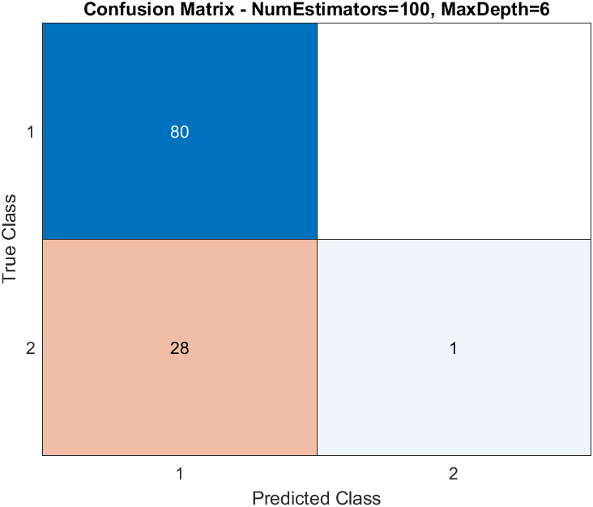

Figure 5.1: Confusion matrix of RF model.

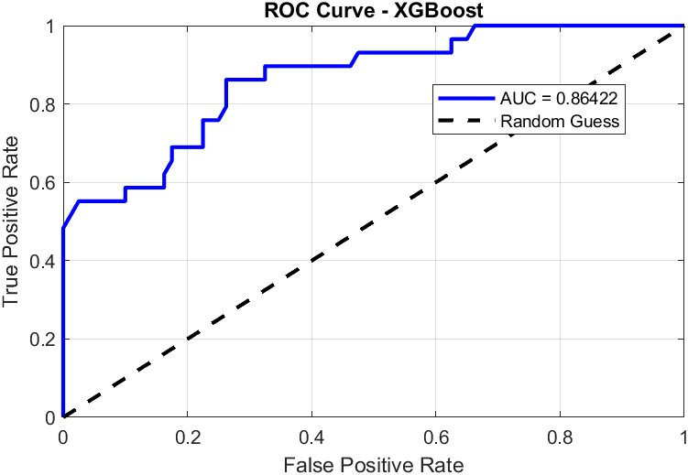

Figure 5.2: ROC curve of RF model.

**5.3 XGBoost Model Result**

**Table 5.2:** Evaluation of XGBoost model.

|  |  |  |  |  |
| --- | --- | --- | --- | --- |
| **Model** | **Accuracy** | **Precision** | **Recall** | **F1 Score** |
| XGBoost | 82.57% | 0.81 | 1.00 | 0.89 |

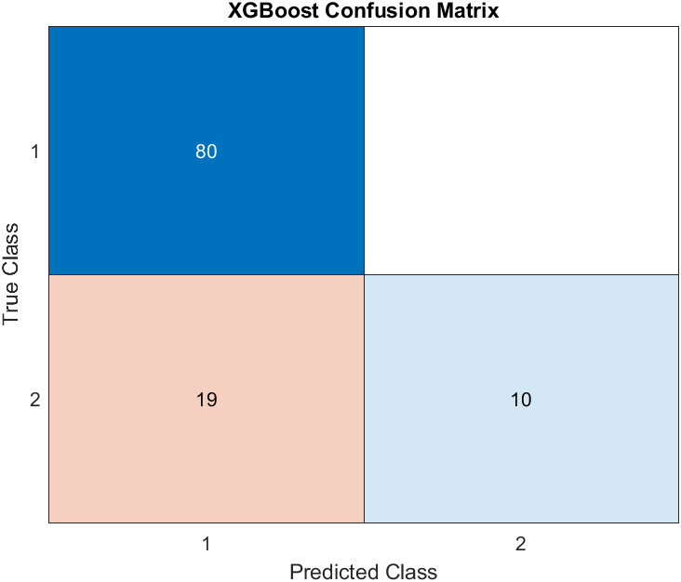

Figure 5.3: Confusion matrix of XGBoost Model.

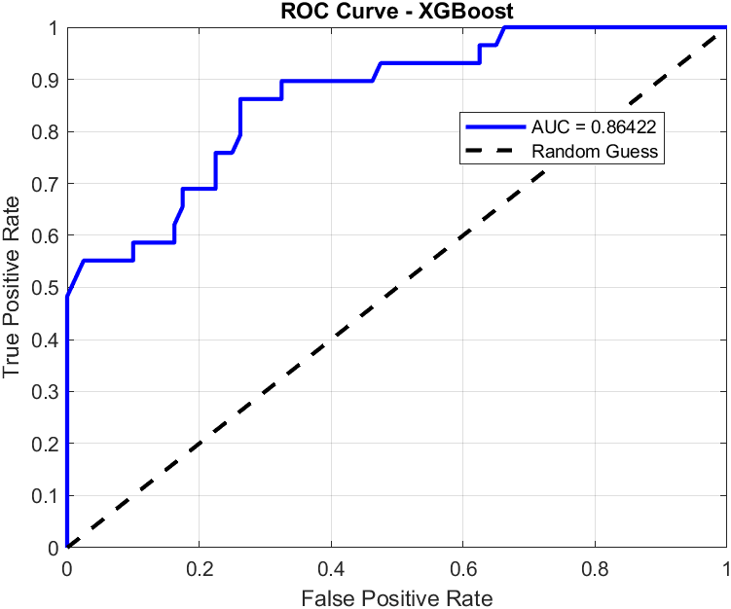

Figure 5.4: ROC Curve of XGBoost Model.

**5.4 Discussion of Model Training Results**

Electroencephalogram (EEG) plays an important role in the detection of depression. To find the best accuracy machine learning technology is proposed in this research. This research considers resting state EEG signals via 19 channels. EEG recording was collected using an electrode elastic cap placed on the participants' scalp to maintain the International 10-20 system rule.

This research used prepossessed data. So there is no need to filter the data. There are six types of disorders such as obsessive-compulsive disorders, addiction disorders, disorders linked to trauma and stress, depression disorders, schizophrenia, and anxiety disorders, and with healthy control data available. We extract depressed and healthy control data for our research.

In this study, two machine learning models - Random Forest, and XGBoost are used to diagnose depression. The study objective is to traits and link those qualities to the appropriate label. We translate these labels to 1 and 2. Models will be trained using particular labels from healthy controls and depressed participants. Two models produced accuracy. Considering two models XGBoost reported higher accuracy with 82.57% accuracy rate.

The suggested strategy offers some advantages. First, it produces more accuracy. This takes less time to train the model which reduces the execution time to the model.

**5.5 Comparative Analysis**

Two classification techniques- XGBoost and Random Forest are used in the design of our model. The best accuracy 82.57% was provided by the XGBoost model. In Electroencephalogram-based depression detection using machine learning techniques where maximum accuracy was found 81% for depression detection. They also used the Random Forest model where the accuracy was found 76%. In our proposed model we get 74.31% for the Random Forest model and 82.57% for the XGBoost model.

**Table 5.3:** List of a few Recent Works**.**

|  |  |  |
| --- | --- | --- |
| **Previous Work** | **Approach** | **Accuracy** |
| [2] | XGBoost | 81% |
| proposed | XGBoost | 82.57% |

The suggested EEG-based depression detection model, utilizing multiple machine learning techniques offers practical benefits. The automation through machine learning reduces clinicians’ workload, speeds up diagnosis, and accommodates various EEG collection methods, making it more flexible and accessible to a wider range of participants.

**Chapter 6**

**Conclusion and Future Work**

**6.1 Conclusion**

This study utilizes a machine learning algorithm to analyze EEG signals for effective depression detection. We use preprocessed data where 95 healthy controls and 266 depressed participants are available. Parameter used in the model based on previous work [2]. This approach showed higher productivity in recognizing depression based on trial data. We use two machine learning models - Random Forest, and XGBoost. XGBoost achieved higher accuracy with an 82.57% accuracy rate

**6.2 Limitation**

Depression detection using machine learning techniques is a complex calculation. To get more accurate results data should be accurate and noise-free. Noise can directly impact data. So careful to selecting data and preprocessed data. Our study can’t handle the data processing part because we used preprocessed data.

**6.3 Future work Direction**

Machine learning-based depression detection was introduced in our proposed method. In the future, the larger dataset can be used to check more accuracy. Also, Deep learning classification will used to get higher accuracy.

**References**

1. Ay, B., Yildirim, O., Talo, M., Baloglu, U. B., Aydin, G., Puthankattil, S. D., & Acharya, U. R. (2019). Automated depression detection using deep representation and sequence learning with EEG signals. Journal of Medical Systems, 43(7), 205.
2. Ksibi, A., Zakariah, M., Menzli, L. J., Saidani, O., Almuqren, L., & Hanafieh, R. A. M. (2023). Electroencephalography-based depression detection using multiple machine learning techniques. Diagnostics (Basel, Switzerland), 13(10).
3. Mahato, S., & Paul, S. (2019a). Detection of major depressive disorder using linear and non-linear features from EEG signals. Microsystem Technologies: Sensors, Actuators, Systems Integration, 25(3), 1065–1076.
4. Mahato, S., & Paul, S. (2019b). Electroencephalogram (EEG) signal analysis for diagnosis of major depressive disorder (MDD): A review. In Nanoelectronics, Circuits and Communication Systems (pp. 323–335). Springer Singapore.
5. Mallikarjun, H. M., & Suresh, H. N. (2014). Depression level prediction using EEG signal processing. 2014 International Conference on Contemporary Computing and Informatics (IC3I).
6. Park, S. M., Jeong, B., Oh, D. Y., Choi, C.-H., Jung, H. Y., Lee, J.-Y., Lee, D., & Choi, J.-S. (2021). Identification of major psychiatric disorders from resting-state electroencephalography using a machine learning approach. Frontiers in Psychiatry, 12, 707581.
7. Saeedi, A., Saeedi, M., Maghsoudi, A., & Shalbaf, A. (2021). Major depressive disorder diagnosis based on effective connectivity in EEG signals: a convolutional neural network and long short-term memory approach. Cognitive Neurodynamics, 15(2), 239–252.
8. Safayari, A., & Bolhasani, H. (2021). Depression diagnosis by deep learning using EEG signals: A systematic review. In Preprints.
9. Wang, B., Kang, Y., Huo, D., Feng, G., Zhang, J., & Li, J. (2022). EEG diagnosis of depression based on multi-channel data fusion and clipping augmentation and convolutional neural network. Frontiers in Physiology, 13, 1029298.
10. Le, J., Lu, M., Pellouchoud, E., & Gevins, A. (1998). A rapid method for determining standard 10/10 electrode positions for high resolution EEG studies. Electroencephalography and Clinical Neurophysiology, 106(6), 554–558.